USED CAR PRICE PREDICTION

2021

Satish Agrawal, SANJAY JARAS

BELlevue university

**Executive Summary**

On average, there are 1.88 vehicles per USA household. Owning a car is becoming more and more common worldwide. The current market size of used vehicles is around $89 billion. The buyer confidence will likely increase over the next five years as the economy recovers from the coronavirus pandemic. It is projected that the revenue for used car dealers in the USA will amount to approximately $123.3 billion by the year 2024[1]. In the US alone, there are 123,905 businesses involved in the used car market. Due to the increased price of new vehicles and customers with the lack of funds, used car sales are on a global increase. Developing countries adopted the lease culture instead of owning a new car due to affordability. Therefore, the rise in used vehicle sales is increasing exponentially.

Used vehicle sales is not a new industry, it has been there for decades and there is an abundance of used car sales data out and available. We picked a large dataset of used vehicle sales over the years from Craigslist and analyzed the feasibility to predict the fair price for a used vehicle. The price of a used vehicle largely depends upon the characteristics of the vehicle. The make and model of the vehicle is one of the most influential parameters that determine the price of the vehicle. For example, an Audi and BMW car is going to cost more than a Toyota or a Honda car. Similarly, it also matters that how old the car is and how much it has been used. A car built in 2018 and has 15000 miles on it, is going to cost more than, a car that was built in 1980 and has 200k miles. Of course, it’s the combination of attributes that determines the final price for the car.

In this project, we used those features and looked at the price the vehicle was listed for, on Craigslist. We have more than 450k instances of vehicle listings that we used to analyze how the final price varies with different parameter combinations. In the end, we came up with a model which has been learned from these observations and can predict the fair price for a used vehicle, given the parameters or attributes of the listed vehicle. In this paper, we will discuss the process of building the model that can predict the final price of a vehicle with more than 93% of accuracy.

**Intro/background of the problem**

The price of the new vehicle is determined by the manufacturer. The manufacturer considers a variety of factors including government taxes, used raw materials cost, the labor involved, intended profit margin per unit, and many other factors that may contribute to the price of the car to come up with the Manufacturer Suggested Retail Price (MSRP). So, buyers of new cars are a bit more confident about the price of new cars; which is not always true with the price of an old car. The used car buying is a very complex process, as an average buyer might not think of all the variables affecting or involved in the price of the vehicle. Car sellers seldom take advantage of such a scenario by listing unfair prices owing to the demand. On the seller's part also it's quite hard to estimate the used car price manually. Generally, experienced sellers can think of some of the parameters like mileage on the vehicle, condition of the vehicle, fuel type, and vehicle age, etc. However, for experienced sellers also, it is hard to consider all parameters while estimating used vehicle price. So, there is a necessity for a used vehicle price prediction system to reliably determine the fair price of the vehicle using various vehicle parameters. There are existing models in the market that estimate the used vehicle price; we are not confident about the accuracy and the quality of the existing models. Depending on the organization that developed these models, those may have biases to benefit the seller.

This project aims to train models for the data set chosen. The data set is one from Craigslist used car listings. We are expecting it to be generalized to the rest of the world and other listing portals.

**Methods**

We chose a data set from Kaggle @ https://www.kaggle.com/austinreese/craigslist-carstrucks-data. This data set has more than 450k records and 25 attributes for each record. We are training a supervised learning model; the target variable is the “price” of the vehicle. We have split our data into the training set and test set to avoid test data getting used in imputation and training. We are dropping a few columns from the start before starting any analysis considering those may not correlate as much (or at all) to contribute to the price of the used vehicle. We dropped unique listing id, image URL, listing URL, region URL, VIN, and description of the car. These columns do not have a direct correlation with the target variable. As part of the data cleansing process, we looked at the distribution of the listing year column. We removed records located outside of the United States by latitude and longitude. We restricted records only from latitude between 25 and 50, and longitude between -125 to -65. We dropped records with extreme values for the year column with a value less than 1995 and more than 2020. We also removed the outliers from the dataset based on the odometer readings and the final price. We removed records with odometer readings of more than 170,000 miles. For removing records by price, we decided to remove records with a price outside of the range of $2000 to $60,000.

As part of feature engineering, we have added a new column for the age of the car at the time of listing. The value for the age in the month is derived from the model year and the date of listing. For the model year month, we considered September of the previous year of the model year as most of the car manufacturers launch their next year's car models in August/September of the current year. We found that the distribution of the age for the data set is a right-skewed distribution with a single peak.

There are many categorical attributes in the data set which are key to our modeling project for price prediction, for example, manufacturer, model, cylinders (number of cylinders), title status, transmission (auto versus manual), fuel (the type of fuel used) and few others. We used ordinal encoding to convert categorical columns into numerical columns to use with model training. We decided to use sklearn’s latest version 0.24 for label encoding. This version gracefully supports the missing labels from unseen data.

We also noticed a significant amount of missing values in a few of the columns. After analyzing the percentage of missing values, we decided to drop the “size” column from further processing. The “size” column has more than 50% missing values.

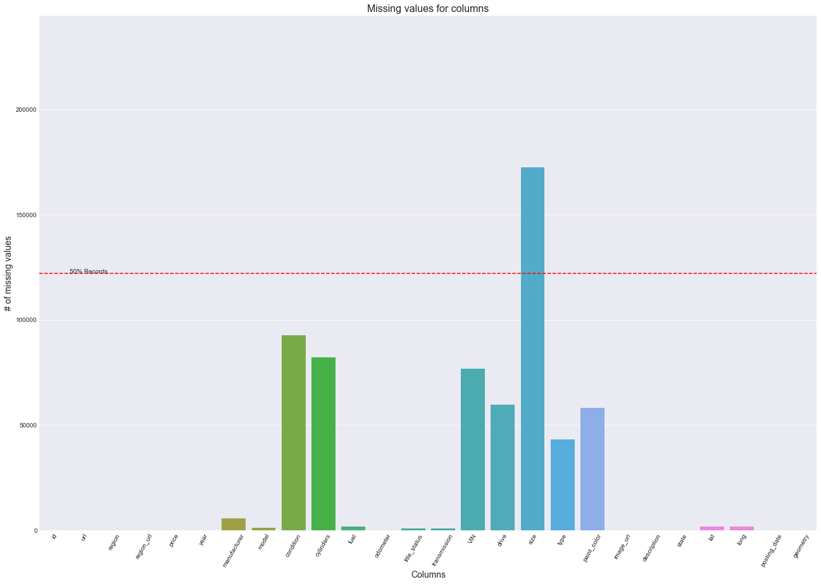

To fill missing values, we implemented iterative imputation using many of the estimators to reduce the mean square error. We chose Bayesian ridge, decision tree regressor, extra trees regressor, K neighbor regressor, and lasso regression and ran through the data set for columns with missing values using the negative mean square error being the scoring metric. It came out to be the Lasso the best imputer for the data set. We finally used the chosen estimator to impute all the missing values.

We further calculated the correlation between all the dependent variables with the target variable. From these correlation numbers, we found that the “state” column has a very small correlation with the target variable. We decided to drop column “state” from our model training. As the result of feature engineering, we added the column age of the vehicle and dropped columns unique listing id, image URL, listing URL, region URL, VIN, Description, state, and size from further processing.

As the values of all the columns are on different scales we decided to use StandardScaler from sklearn to normalize the values. We created pipelines for all the above operations so that we can perform the same kind of operations on the test dataset as well as the future data after model deployment.

For model selection, we used an exhaustive search technique. We decided to use the following different algorithms for the exhaustive search LinearRegression, DecisionTreeRegressor, XGBRegressor, RandomForestRegressor, KNeighborsRegressor, Ridge, and Lasso. Out of 400K plus records in the training set, we used only 50K records for an exhaustive search to avoid the crashing of the program while training models for model selection. We used Sklearns’ Grid Search Cross-validation method for this purpose. This method allows us to train multiple models of the same or different algorithms with several hyperparameters. We used 5-fold Stratified cross-validations. Stratified split tries to keep the same number of records of each category in every split. Grid search trains all the models with a different combination of splits, algorithms, and hyperparameters. Grid search returns the score for each model as a result. We decided to use R-square as a scoring metric. The most common interpretation of r-squared is how well the regression model fits the observed data.

**Results**

In the exhaustive search process, we ended up training 280 models on the training dataset(50K records). After a comparison of scores of models, we found the XGBRegressor as the best model. It has a score of 0.9061 followed by RandomforestRegressor with a 0.8722 score on the training dataset(50K records).

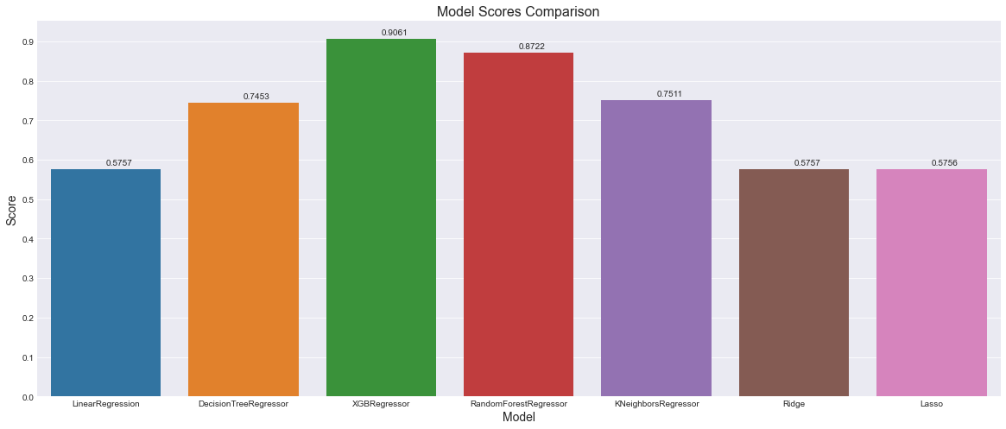

We decided to use XGBRegressor with the best hyperparameter found in the grid search as our final model for training and deployment. After training the XGBRegressor model on the full training dataset, we tested it with the test dataset.

We split the data set into train and test set using an 80-20 split before starting any processing. We want to make sure that we have some unseen data set aside for the model to see how it performs. When we tested the trained XGBRegressor model with the test dataset, we saw an R2 score of 93.42%. This accuracy indicates that more than the predicted price is ~93% closer to the actual price. This model is a great achievement and can be used in a real-world scenario to predict the price.

**Discussion/conclusion**

In this project, we decided to train multiple models. There are many advantages of training multiple models including, we get to compare them and choose the best performing model. It is not easy to choose the right hyperparameters for each of the models while training. Training multiple models enable us to checkout combinations of hyperparameters and select the one with the best accuracy. The final model chosen is XGBoost which has become one of the most used tools in machine learning. It consists of an ensemble of decision trees (also known as GBDT, GBM), where each new tree depends on the evaluation of the previous one. XGBoost is an optimized distributed gradient boosting library and it is highly efficient, flexible, and portable. It implements machine learning algorithms under the Gradient Boosting framework.

We had quite a few categorical attributes in the dataset. We tried out using one-hot encoding which was increasing the number of attributes by multi-folds as each one of the categorical variables had too many categories. We ended up using ordinal encoding and it worked fine for us. We strongly believe that using one-hot encoding and then Principle component analysis will increase the performance of the model and will be able to predict better.

**Acknowledgments**

The authors of this project have referred to Kaggle for the data set and some of the notebooks available in the Kaggle. There is a significant number of solutions available on the Internet for the problem. We have referred to some of those available solutions and have designed our solution. We have also referred to multiple websites including data science articles from various authors, geeks for geeks, machine learning websites, mediam.com, and many others for the basic machine learning and statistics concepts and practical examples. We acknowledge Professor Werner’s guidance and help in the success of this project.

**References**

1. IBIS world Oct 14, 2020 - Used Car Dealers Industry in the US - [**https://www.ibisworld.com/united-states/market-research-reports/used-car-dealers-industry/**](https://www.ibisworld.com/united-states/market-research-reports/used-car-dealers-industry/)
2. Aurélien Géron – June 2019 - Hands-on Machine Learning with Scikit-Learn, Keras, and TensorFlow – O’Reilly Publication
3. Panwar Abhash - Used Car Price Prediction using Machine Learning - https://towardsdatascience.com/used-car-price-prediction-using-machine-learning-e3be02d977b2
4. Used car dataset - <https://www.kaggle.com/austinreese/craigslist-carstrucks-data>
5. Enes Gokce - Predicting Used Car Prices with Machine Learning Techniques - <https://towardsdatascience.com/predicting-used-car-prices-with-machine-learning-techniques-8a9d8313952>
6. XGBoost - <https://xgboost.readthedocs.io/en/latest/index.html>